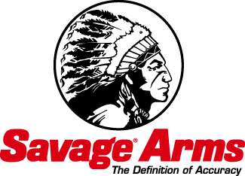

Contact: JJ Reich
Public Relations Specialist
763-323-3862
FOR IMMEDIATE RELEASE E-mail: pressroom@atk.com

Savage Arms and CCI Ammunition to Host Shooting Sports Celebrities at the 2015 SHOT Show

Savage Arms™ and CCI® Ammunition are proud to host several shooting sports ambassadors in the ATK Sporting Group booth at the 2015 SHOT Show in Las Vegas, Jan. 20-22. Troy Landry, Jacob Landry, Chase Landry, Mike Stroff and the Savage Outdoors Team will all be making appearances.

SUFFIELD, Conn. – January 15, 2015 – Savage Arms™ will host a variety of shooting sports celebrities in the ATK Sporting Group booth (#14551) at the 2015 SHOT Show in Las Vegas, Jan. 20-22. Mike Stroff and the Savage Outdoors Team, as well as Troy, Jacob and Chase Landry (also sponsored by CCI® Ammunition), will be on hand throughout the show to meet fans and answer questions.

Mike Stroff and the rest of the Savage Outdoors Team travel North America capturing some of the most intense hunting action ever caught on film. They chase trophy whitetails in South Texas, bull elk in the Rocky Mountains and more. Stroff and the Savage Outdoors Team will be in booth #14551 on Tuesday, Jan. 20 from 12 to 1 p.m. and Wednesday, Jan. 21 from 4 to 5 p.m. Attendees are invited to speak with Stroff and the rest of the team and watch some of their amazing videos.

The Landrys make their living on the dark and murky waters of the Louisiana swamps. They will be available to meet fans from 2 to 3 p.m. on Tuesday, Jan. 20; Wednesday, Jan. 21; and Thursday, Jan. 22. The three life-long outdoorsmen will share stories and explain the advantages of the new Landry Signature Series rifles from Savage Arms.
And when it comes time to “choot ’em,” they chamber only one brand of rimfire ammunition: CCI.

To learn more about the entire line of Savage firearms and CCI Ammunition, visit www.savagearms.com and www.cci-ammunition.com.

